Toggle Flip-Flop (T Flip-Flop)
The output of a toggle flip-flop, also called a T flip-flop, changes state every time it is triggered at its T input, called the toggle input. That is, the output becomes ‘1’ if it was ‘0’ and ‘0’ if it was ‘1’.
The figures below show the circuit symbols of positive edge-triggered and negative edge-triggered T flip-flops, along with their function tables.
It is obvious from the operational principle of the T flip-flop that the frequency of the signal at the Q output is half the frequency of the signal applied at the T input. A cascaded arrangement of n T flip-flops, where the output of one flip-flop is connected to the T input of the following flip-flop, can be used to divide the input signal frequency by a factor of 2^{n}. Below is a figure showing a divide-by-16 circuit built around a cascaded arrangement of four T flip-flops.
J-K Flip-Flop as a Toggle Flip-Flop
If we recall the function table of a J-K flip-flop, we will see that, when both J and K inputs of the flip-flop are tied to their active level (‘1’ level if J and K are active when HIGH, and ‘0’ level when J and K are active when LOW), the flip-flop behaves like a toggle flip-flop, with its clock input serving as the T input. In fact, the J-K flip-flop can be used to construct any other flip-flop. That is why it is also sometimes referred to as a universal flip-flop.
When the second flip-flop (FF-2) is a positive edge-triggered one, it will respond to the LOW-to-HIGH edges of the waveform appearing at its T input, which is the waveform appearing at the Q output of FF-1. The relevant waveforms in this case are shown.
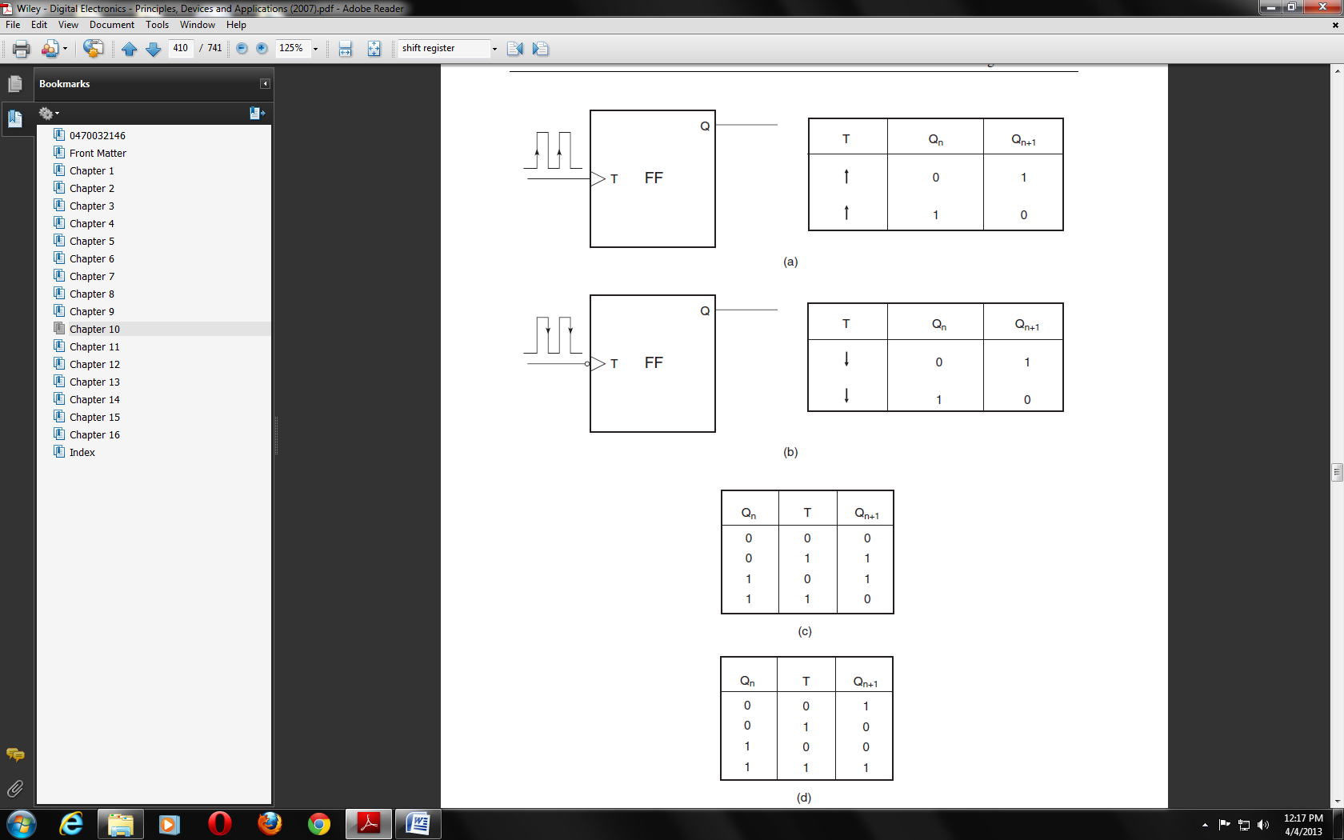
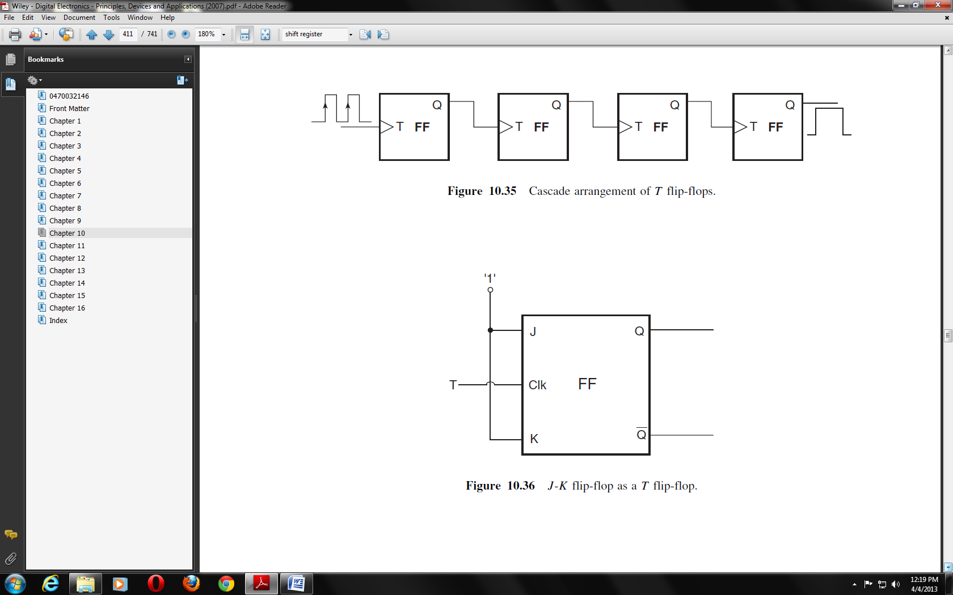
Cascaded arrangement of T flip-flops

J-K flip-flop as a T flip-flop
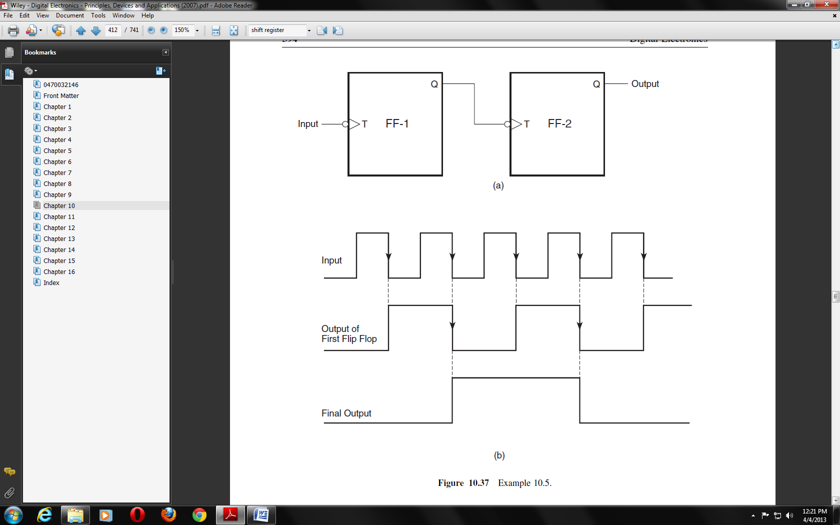
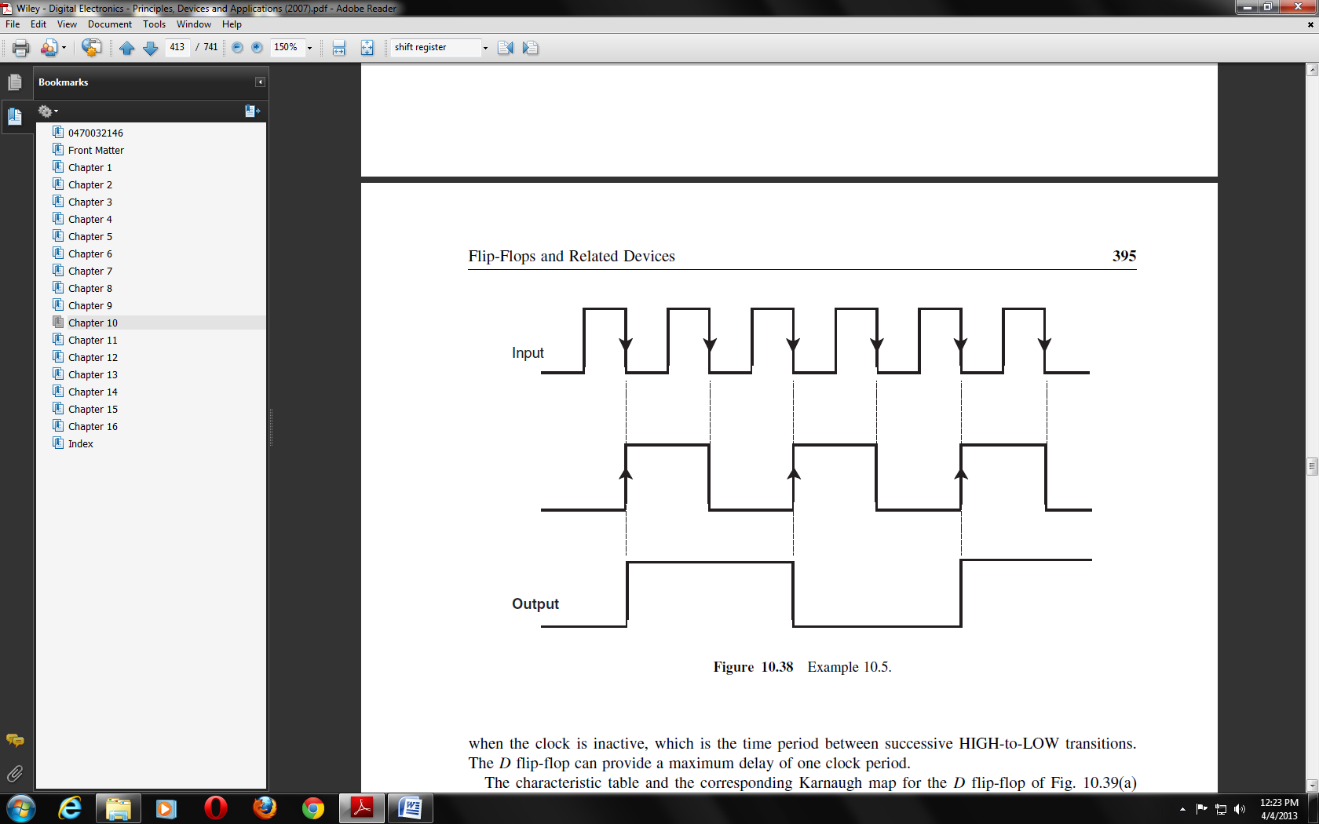

D Flip-Flop
A D flip-flop, also called a delay flip-flop, can be used to provide temporary storage of one bit of information. The figure below shows the circuit symbol and function table of a positive edge-triggered D flip-flop. When the clock is active, the data bit (0 or 1) present at the D input is transferred to the output. In the D flip-flop of this figure, the data transfer from D input to Q output occurs on the positive-going (LOW-to- HIGH) transition of the clock input. The D input can acquire new status when the clock is inactive, which is the time period between successive LOW-to- HIGH transitions. The D flip-flop can provide a maximum delay of one clock period.
J-K Flip-Flop as D Flip-Flop
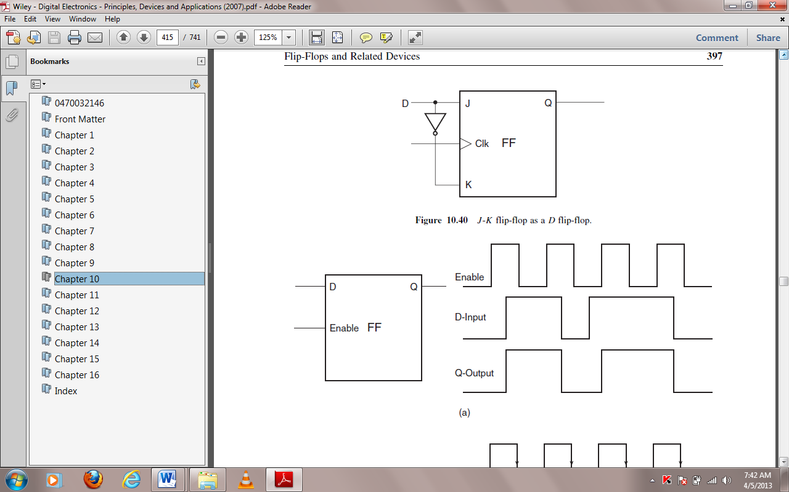
The figure below shows how a J-K flip-flop can be used as a D flip-flop. When the D input is a logic‘1’, the J and K inputs are a logic ‘1’ and ‘0’ respectively. According to the function table of the J-K flip-flop, under these input conditions, the Q output will go to the logic ‘1’ state when clocked. Also, when the D input is a logic ‘0’, the J and K inputs are a logic ‘0’ and ‘1’ respectively. Again, according to the function table of the J-K flip-flop, under these input conditions, the Q outputs will go to the logic ‘0’ state when clocked. Thus, in both cases, the D input is passed on to the output when the flip-flop is clocked.


Shift Register
A shift register is a digital device used for storage and transfer of data. The data to be stored could be the data appearing at the output of an encoding matrix before they are fed to the main digital system for processing or they might be the data present at the output of a microprocessor before they are fed to the driver circuitry of the output devices. The shift register thus forms an important link between the main digital system and the input/output channels. The shift registers can also be configured to construct some special types of counter that can be used to perform a number of arithmetic operations such as subtraction, multiplication, division, complementation, etc. The basic building block in all shift registers is the flip-flop, mainly a D-type flip-flop. Although in many of the commercial shift register ICs their internal circuit diagram might indicate the use of R-S flip-flops, a careful examination will reveal that these R-S flip-flops have been wired as D flip-flops only.
The storage capacity of a shift register equals the total number of bits of digital data it can store, which in turn depends upon the number of flip-flops used to construct the shift register. Since each flip-flop can store one bit of data, the storage capacity of the shift register equals the number of flip-flops used. As an example, the internal architecture of an eight-bit shift register will have a cascade arrangement of eight flip-flops.
Based on the method used to load data onto and read data from shift registers, they are classified as serial-in serial-out (SISO) shift registers, serial-in parallel-out (SIPO) shift registers, parallel-in serial-out (PISO) shift registers and parallel-in parallel-out (PIPO) shift registers.
The figure below shows a circuit representation of the above-mentioned four types of shift register.
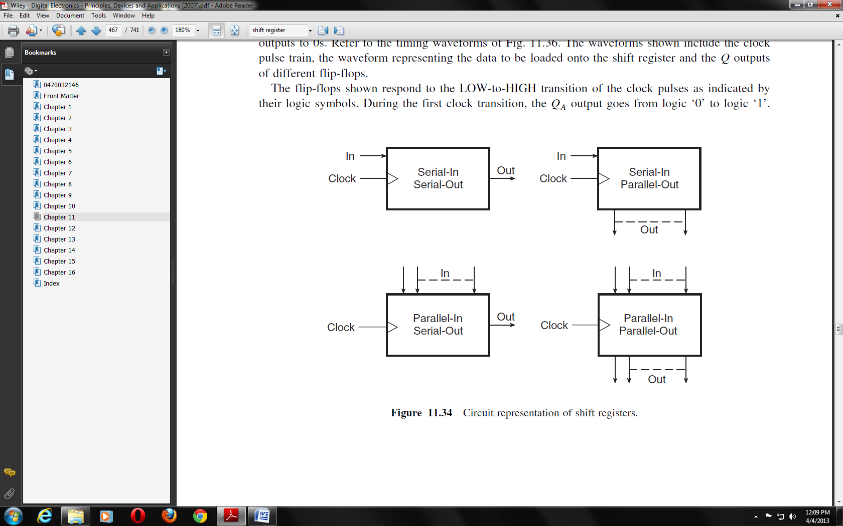
Serial-In Serial-Out Shift Register
The figure below shows the basic four-bit serial-in serial-out shift register implemented using D flip-flops.
The circuit functions as follows. A reset applied to the CLEAR input of all the flip-flops resets their Q outputs to 0s. Refer to the timing waveforms shown. The waveforms shown include the clock pulse train, the waveform representing the data to be loaded onto the shift register and the Q outputs of different flip-flops.
The flip-flops shown respond to the LOW-to-HIGH transition of the clock pulses as indicated by their logic symbols. During the first clock transition, the QA output goes from logic ‘0’ to logic ‘1’. The outputs of the other three flip-flops remain in the logic ‘0’ state as their D inputs were in the logic‘0’ state at the time of clock transition. During the second clock transition, the QA output goes from logic ‘1’ to logic ‘0’ and the QB output goes from logic ‘0’ to logic ‘1’, again in accordance with the logic status of the D inputs at the time of relevant clock transition. Thus, we have seen that a logic ‘1’ that was present at the data input prior to the occurrence of the first clock transition has reached the QB output at the end of two clock transitions. This bit will reach the QD output at the end of four clock transitions. In general, in a four-bit shift register of this type, a data bit present at the data input terminal at the time of the nth clock transition reaches the QD output at the end of the (n+4)^{th} clock transition. During the fifth and subsequent clock transitions, data bits continue to shift to the right and at the end of the eighth clock transition the shift register is again reset to all 0s. Thus, in a four-bit serial-in serial-out shift register, it takes four clock cycles to load the data bits and another four cycles to read the data bits out of the register.
The contents of the register for the first eight clock cycles are summarized in the table shown. We can see that the register is loaded with the four-bit data in four clock cycles and also that the stored four-bit data are read out in the subsequent four clock cycles.
